**PH233 End-semester exam Module E**

**Final, closed loop feedback control system**

All the ingredient blocks (Fig 1) required for a closed loop feedback control system should have been built and tested with earlier Modules A – D.  
 We are now ready to ‘close’ the feedback loop

Fig 1: All ingredient blocks required for the closed loop feedback control system (Modules A – D)

AIM of this final module E is to fine-tune KP in the controller to get a working system!

**PLANT (Modules A+B)**

CONTROLLER  
(Module C)

–

**+**

LED

SENSOR

BREADBOARD

**E.1) Calibration of response of the feedback control system**Before we use the system to measure an unknown external disturbance, it is necessary to calibrate it’s response using a known disturbance.

Use the following steps to perform the calibration:

**E.1.1) Test stability 10**

Connect all the blocks of the feedback control system in Fig 1 to ‘close’ the loop.

Set . This is about midway in the range of LED drive and photo-transistor response voltages. Set the proportional controller gain to be around

In steady state, the LED should be at about middle of the brightness level, and the sensor response should also be around the middle of its range.

Check the following voltage measurements with DSO/DMM in your feedback control system and record them here with a photo:

1. **Basic sanity checks**: Is the LED approximately half bright and not visibly blinking? Perceptible blinking likely means your feedback control is oscillating.  
   Check ILED  by probing Vshunt in the LED actuator module on the DSO probe. If it shows large oscillations, reduce the value of KP proportional gain and adjust Vadjust until your ILED does not oscillate. There may be residual electronic noise. The point is to tune KP down to a point where such noise does not cause the system to break out into oscillations.
2. error should be close to zero (will never be exactly zero in a **P** controller)  
   What is your ?

0.53V

1. driving the LED  
   What is your ?

2.49V

1. from the photo-transistor  
   What is your ?

1.53V

If your feedback system is all correct and stable in negative feedback, the above values should be nearly constant with time (you can also check as a function of time with the DSO probe on a long time base)

Note the final values used to arrive at stable operating conditions:

used = 10 (no LED oscillation experienced)

offset voltage adjustment used in the P controller = 2V

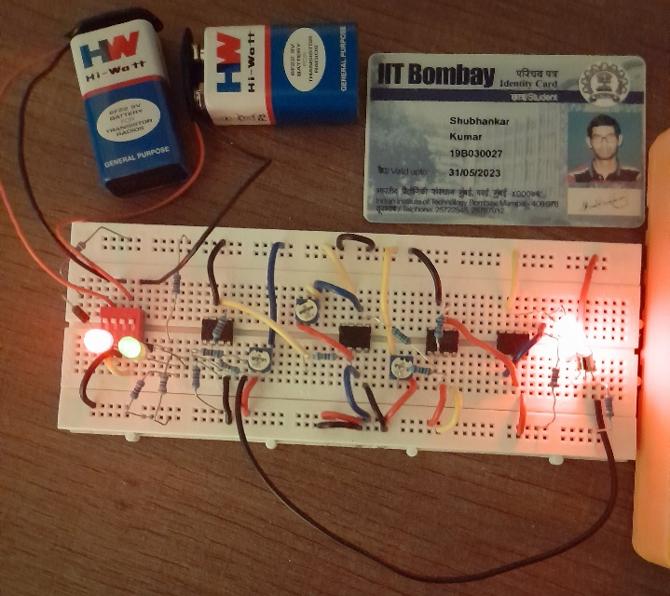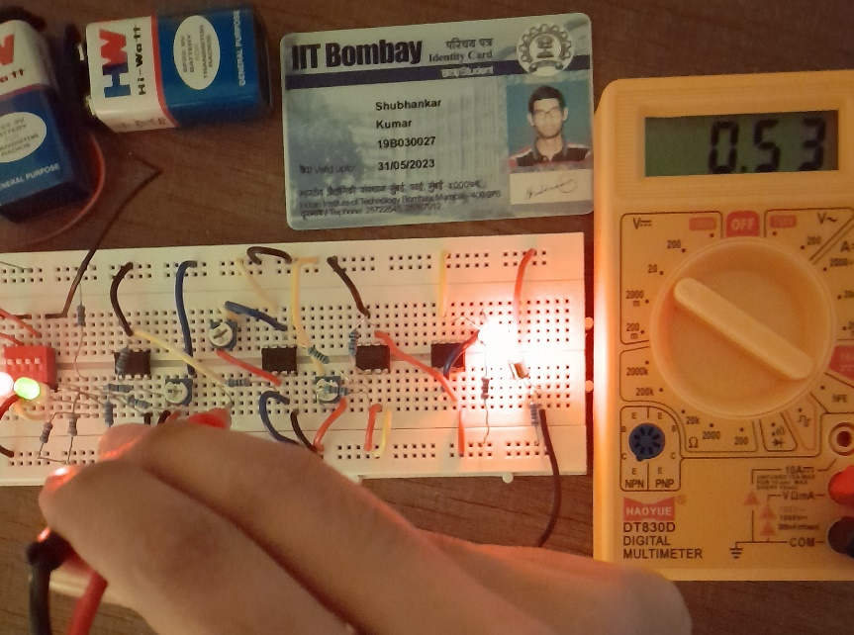

**Circuit design e(t) = 0.5V**

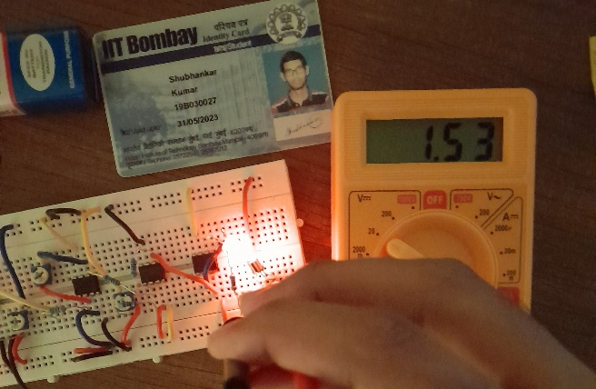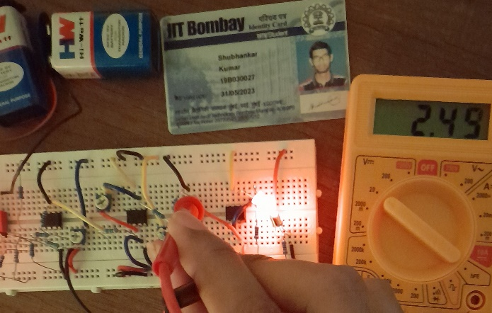

**VOUT|Controller = 2.49V Vsensor = 1.53V**

**E.1.2) Test response of known disturbance introduced into the system 10**

Our plant consists of the LED + photo-transistor tightly coupled through a black straw.

Since we don’t have a FG for this lab, use a cellphone flashlight to introduce a known disturbance into the system as shown in the figure below:

LED

SENSOR

BREADBOARD



Suggested setup for injecting calibrated disturbance into system.   
Use an app like **‘Strobily’** to set your cellphone light to flicker at a fixed frequency (100Hz).   
Hold the camera at a fixed distance from the breadboard setup for a repeatable measurement

AIM:   
Shine bright light on your setup and measure correlated to the strength and frequency of disturbance. The above figure shows one method of performing this action using an app called **‘Strobily’** or equivalent available on the app store for your phone.

Note that this experimental demo has a chicken-and-egg issue. You need to use your cellphone light strobe to inject the disturbance, and then also use your cellphone camera to take a photo of your measurement! Use a second cellphone if available to take the photo. Or set the DSO time axis on a long-time base (0.5 sec per division). Shine the strobe light – observe the disturbance on your DSO screen. Press ‘HOLD’ button on top right of the DSO to pause the data acquisition. Take a photo of the DSO screen. Don’t forget to toggle off the ‘HOLD’ mode so that the DSO resumes normal running.

Perform this measurement with the cellphone flashlight kept at a distance d1 = 2cm and 2×d1 from your plant setup. Since light intensity decreases as 1/r2, the measured amplitude for 2×d1 should be approximately ¼ that for d1 . You may need to experiment with different values of d1 and d2

Record photos of your measurement here:

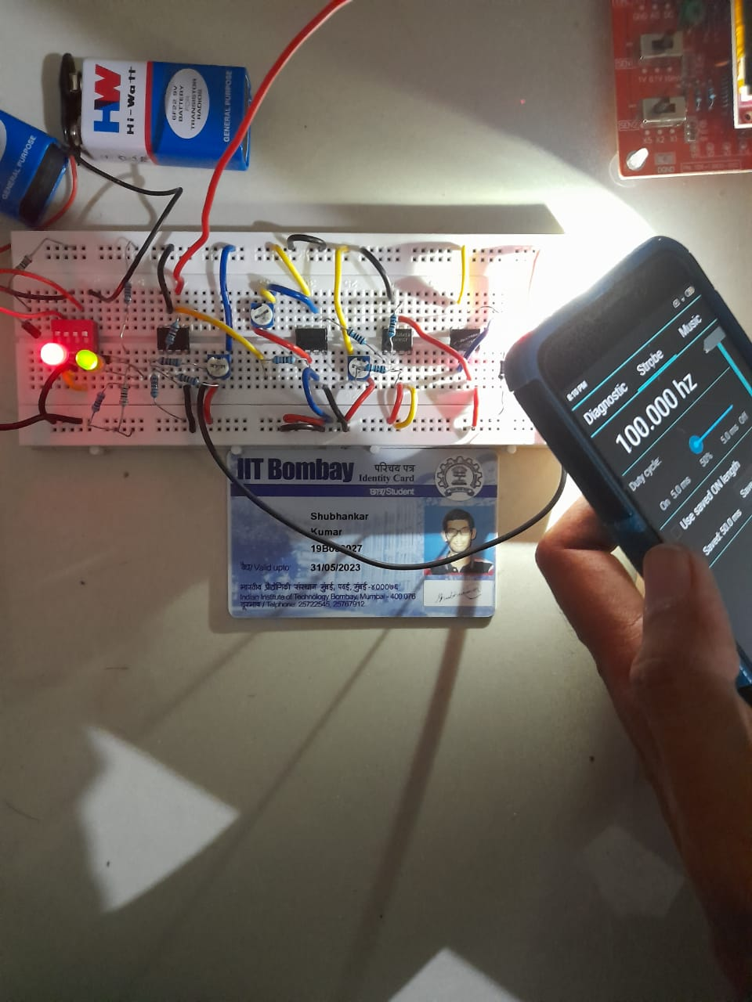

**Setup**

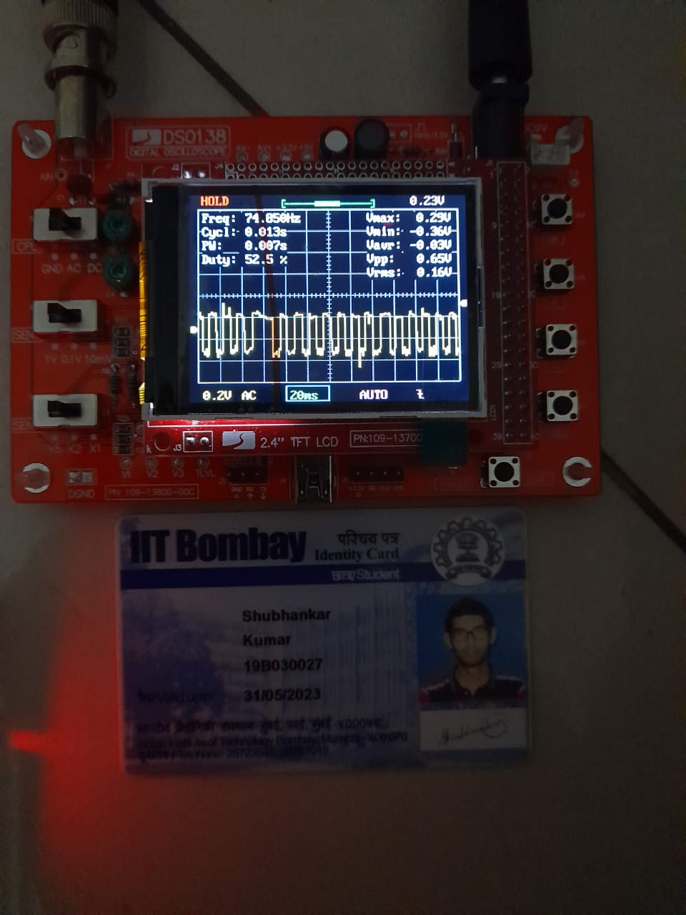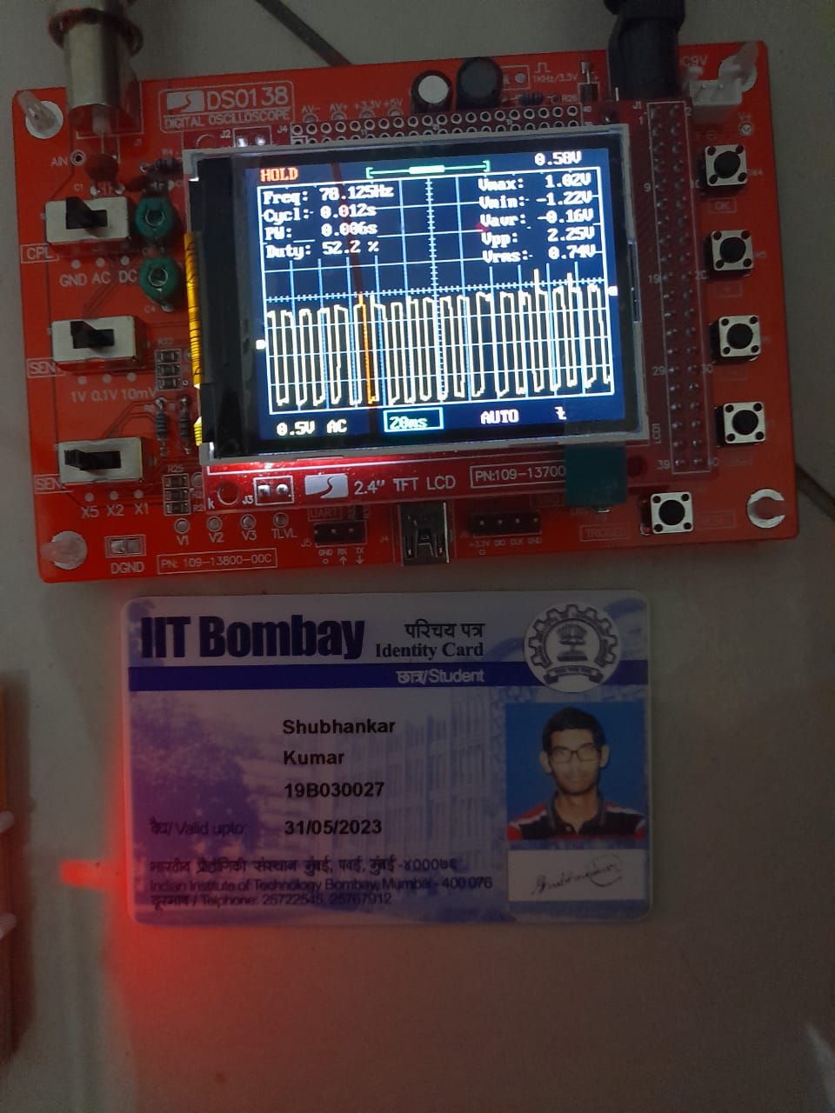

**d = 2cm d = 4cm**

Amplitude measured with disturbance source at d1 = 1.02V

Amplitude measured with disturbance source at 2×d1 = 0.29V

This does not give us an absolute calibration of (volts) light incident because typically we don’t know the absolute value of light flux emitted by the cellphone flashlight. But it gives us a relative calibration for when we measure an unknown disturbance in the next question.

Note: in case your phone flashlight is not working, or an app like Strobily is not available for your phone, you can use a fixed second LED current controlled to high brightness from VCC. Use a momentary switch in series with VC to turn on/off the LED and inject pulse like disturbances into your feedback control system. Measure the corresponding with DSO

**E.2) Measure unknown disturbance signal incident on light sensor**

By now you should have a fully tested, stable and calibrated feedback control system. It is time to take the wrapping off the package and measure unknown disturbance injected into the system!

LED

SENSOR

BREADBOARD

For final measurement  
Remove the straw wrapping around the LED + photo-transistor. Make sure to keep the distance between them the same as calibrated in E.1.2   
Now the phototransistor is exposed to ambient disturbances

Unknown external disturbance to be measured

Here are two types of disturbances you can measure and record with your ‘prototype gravity-wave-aka-light-disturbance-detector’

**10 marks – E.2.1 or E.2.2 or student’s own new idea**

**E.2.1)** If you have an overhead fluorescent tubelight (the old fashioned type, with a choke and a capacitor). The light from those tubelights flickers at ~100Hz (double the AC line frequency of 50Hz) due to their internal working mechanism.

A clear signature of measuring this light disturbance would be a 100Hz trace for measured on your DSO. Take a photo of such a measurement, and record the amplitude of observed, correlating it to units of ‘cellphone flashlight brightness’ as calibrated in the earlier question E.1.2

**E.2.2)** Day/night variation of light intensity in your room. This is a harder measurement since it’s a DC light level. You may think that you will get a different measurement with a DMM during the daytime than night time. However, the feedback control system by definition tends to minimize . So and may be different during day and night, but should be approximately the same for a stable, tuned feedback control system.

You might be able to capture a DSO trace showing changing (on a long time scale) at sunset/sunrise time when you turn ON/OFF the lights in your room.

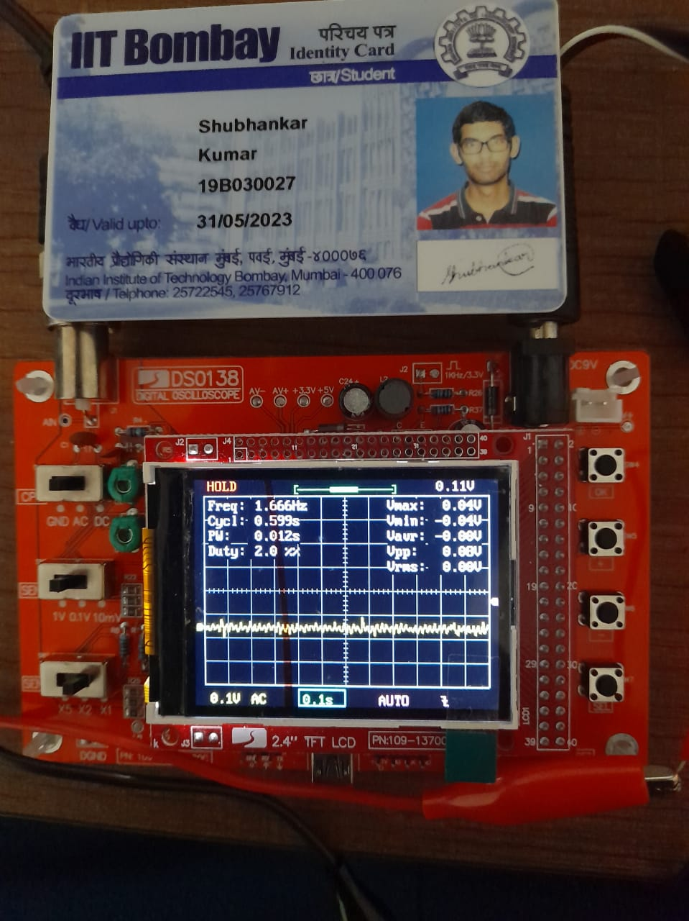

**e(t) when there is no light**

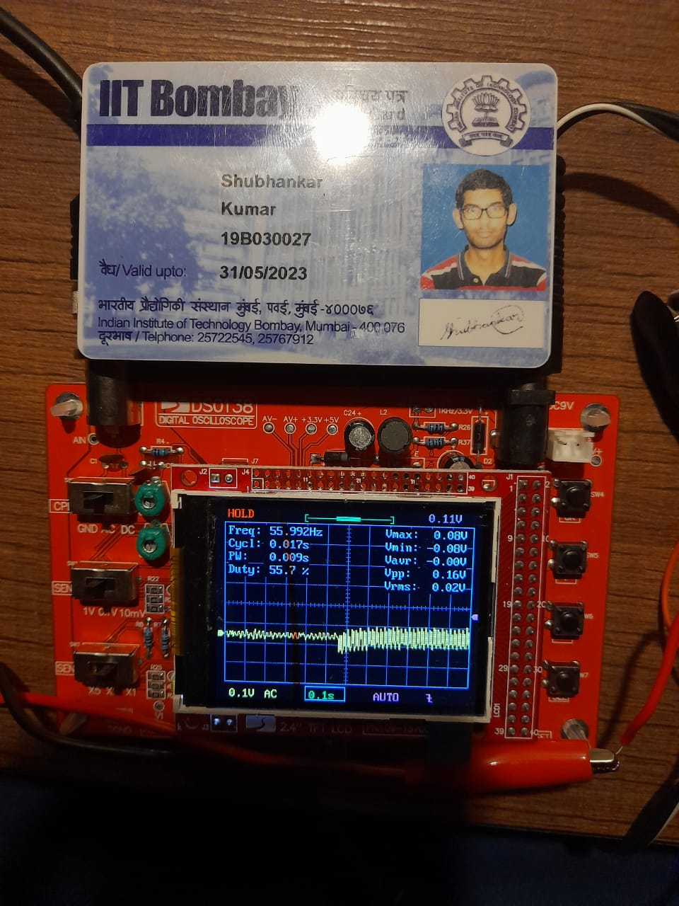

**e(t) when light is just turned on**

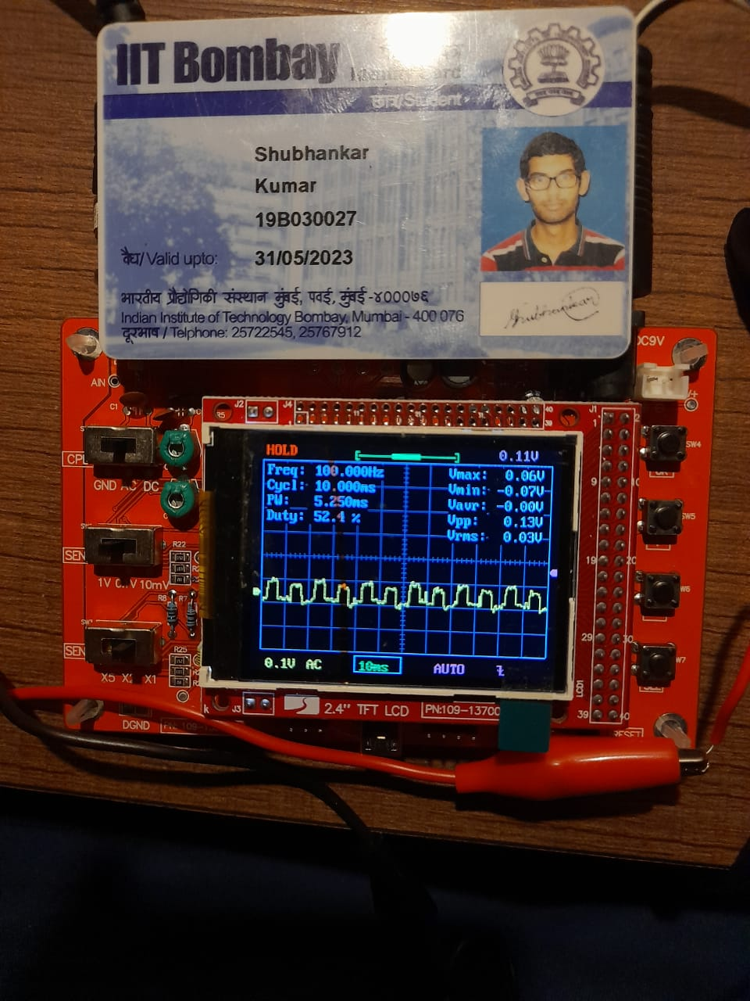

**e(t) after the light is turned on**